# DAY05 Text Formatting in Microsoft Word

This guide will introduce you to some of the most commonly used text formatting tools in Microsoft Word. With these tools, you can enhance the appearance and readability of your documents.

# Changing Font Size

1. **Select the text** you want to format. You can click and drag your mouse to highlight the text.

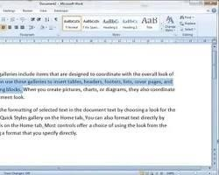

1. Navigate to the **Home** tab on the ribbon.

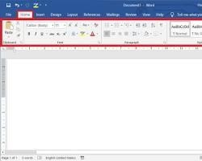

1. In the **Font** group, locate the **Font Size** dropdown menu.

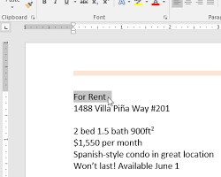

1. Click the dropdown menu and choose the desired **font size**. The most common sizes are listed, but you can also enter a specific size in the box.

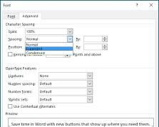

# Applying Bold and Italics

1. **Select the text** you want to format.
2. In the **Font** group on the **Home** tab, locate the **Bold** (B) and **Italic** (I) buttons.
3. Click the **Bold** button (B) to make the selected text bold.

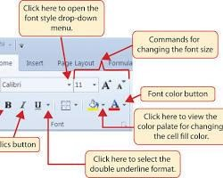

1. Click the **Italic** button (I) to make the selected text italic.

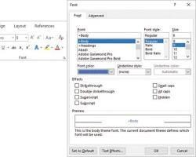

# Underlining Text

1. **Select the text** you want to underline.
2. In the **Font** group on the **Home** tab, locate the **Underline** button (U).

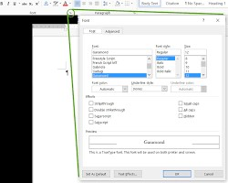

1. Click the **Underline** button (U) to underline the selected text. You can also choose from different underline styles (single, double, wavy, etc.) by clicking the small arrow next to the button. **Additional Tips**

* You can combine these formatting options. For example, you can make text bold and italic at the same time.
* The formatting toolbar also provides quick access to these options. You can customize the toolbar to display the formatting options you use most frequently.

This guide covered some basic text formatting tools in MS Word. By using these tools effectively, you can create professional-looking documents that are easy to read and navigate.